DATA ANALYSIS INTERNSHIP – DAY 16 REPORT
Organization: Top Tech Developers
Topic Covered: Power BI Dashboard Creation and Visualization for Student Dataset

Introduction
Microsoft Power BI is a business analytics and data visualization tool used to create interactive dashboards and reports. It helps in analyzing datasets using charts, graphs, KPI cards, filters, and visual themes for better understanding of information.
On Day 16 of the internship, an interactive dashboard was created using a Student Performance dataset. Different visualizations such as bar charts, line charts, pie charts, and KPI cards were used to analyze student performance and study patterns effectively.

1. Dataset Used
The Student Performance dataset used for the dashboard contained the following columns:
- Student Id
- Gender
- Weekly Self Study Hours
- Mathematics Score
- Physics Score
- Chemistry Score
- Biology Score
- English Score
- Geography Score
- Grade
The dataset was imported into Microsoft Power BI for creating visual reports and dashboards.

2. Dashboard Features Used
Different visualization components were added to the dashboard for better data analysis and representation.
Visualizations Created
1. Bar Chart
Purpose:
- Used for grade comparison
- Compared student performance categories visually
Observation:
- Most students belonged to the Good category
- Students with higher scores achieved Excellent grades

2. Line Chart
Purpose:
- Used for weekly self-study hours analysis
- Showed relationship between study hours and performance
Observation:
- Students with higher study hours generally scored better marks
- Regular study patterns improved academic performance

3. Pie Chart
Purpose:
- Used for subject percentage distribution
- Represented contribution of subject scores visually
Observation:
- Subject-wise distribution became easier to understand
- Percentage comparison helped identify stronger subjects

4. KPI Card
Purpose:
- Displayed total weekly study hours
- Highlighted important numerical insights directly on the dashboard
Observation:
- KPI cards improved dashboard readability
- Important values could be identified quickly
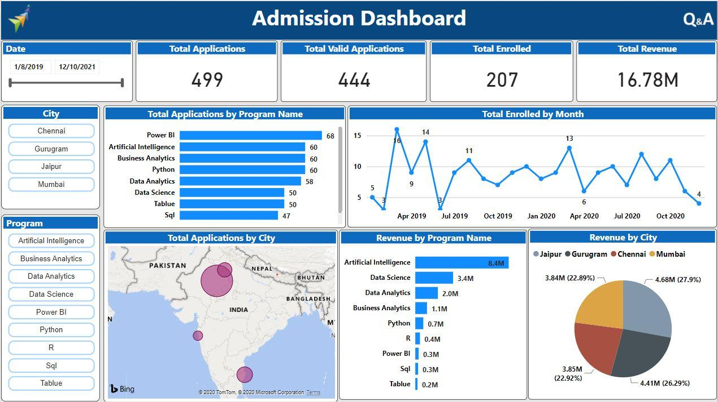
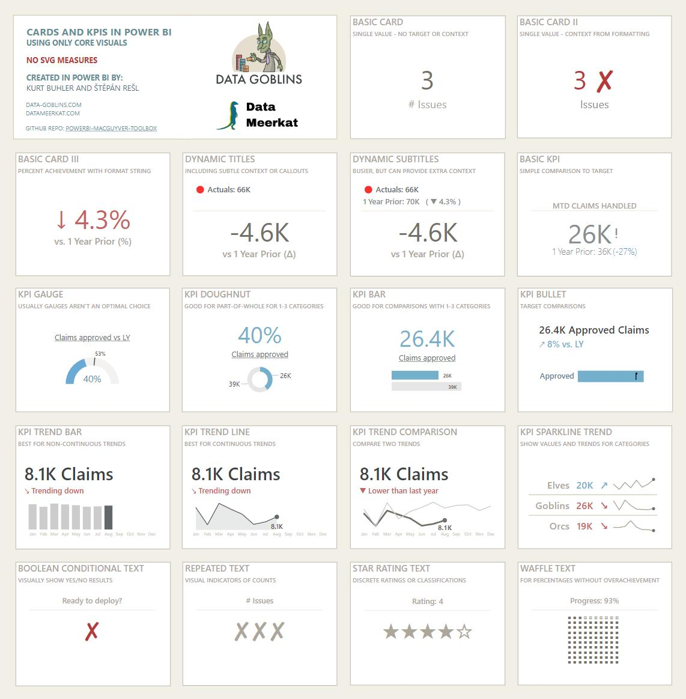
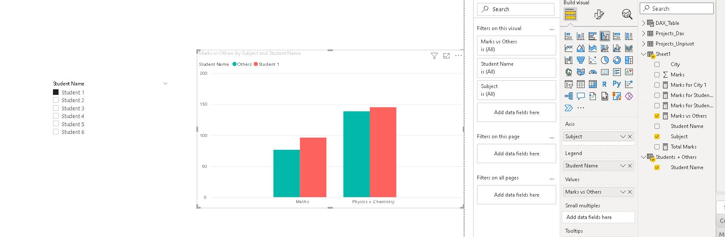
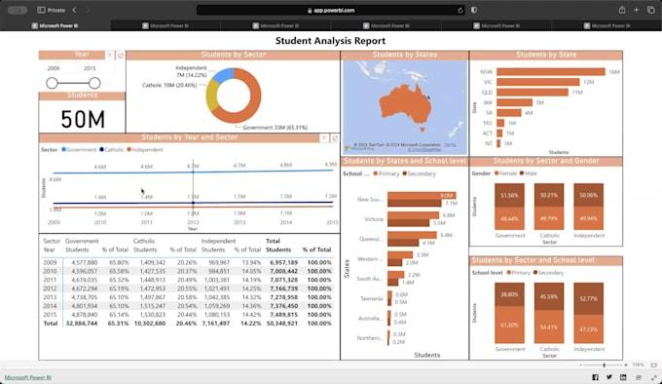

3. Theme Customization
Dashboard appearance was customized using lavender-based colors to improve visual attractiveness and readability.
Component | Color Code
Overall Background Color | #EEE6FF
Visual Background Color | #3B0764
Bar Color | #C4B5FD
Title Color | #F5F3FF
Axis Color | #DDD6FE
Border Color | #7C3AED

4. Dashboard Formatting Features
The following formatting options were applied:
- Customized visual backgrounds
- Chart color customization
- Title formatting
- Border styling
- Axis formatting
- Interactive visual arrangement
Observation:
- Proper formatting improved dashboard appearance
- Attractive visuals made analysis easier and more understandable
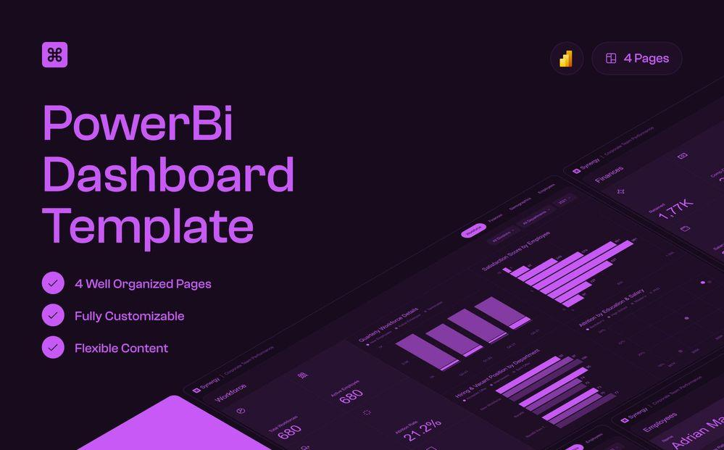
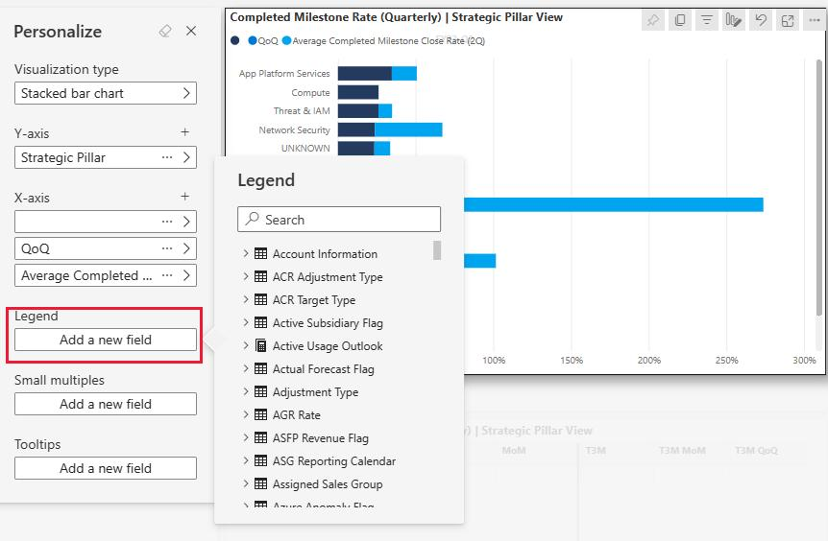



5. Overall Analysis
The dashboard helped in analyzing:
- Student grade distribution
- Study hour patterns
- Subject-wise performance
- Overall academic insights
Important Insights Identified:
- Higher study hours improved student performance
- Balanced subject scores resulted in better grades
- Visual charts simplified performance comparison
- KPI cards highlighted important dataset values clearly

Technologies Used
- Microsoft Power BI
- Microsoft Excel
- Python
- Data Visualization
- Dashboard Design
- Data Analytics

Learning Outcome
On Day 16, I learned how to create interactive dashboards using Microsoft Power BI.
I understood:
- how to import datasets into Power BI
- how to create charts and KPI cards
- how to customize dashboard themes and colors
- how dashboards improve data visualization and analysis
- how interactive visuals help identify patterns and insights easily

Conclusion
The Day 16 internship session helped me understand the fundamentals of dashboard creation and visualization using Microsoft Power BI.
Different visualizations such as bar charts, line charts, pie charts, and KPI cards were created successfully to analyze student performance data. Theme customization and visual formatting techniques improved the appearance and readability of the dashboard. This session enhanced my practical knowledge of business intelligence and interactive data visualization.

